THE FOREST
Play
Written by Lia Romeo

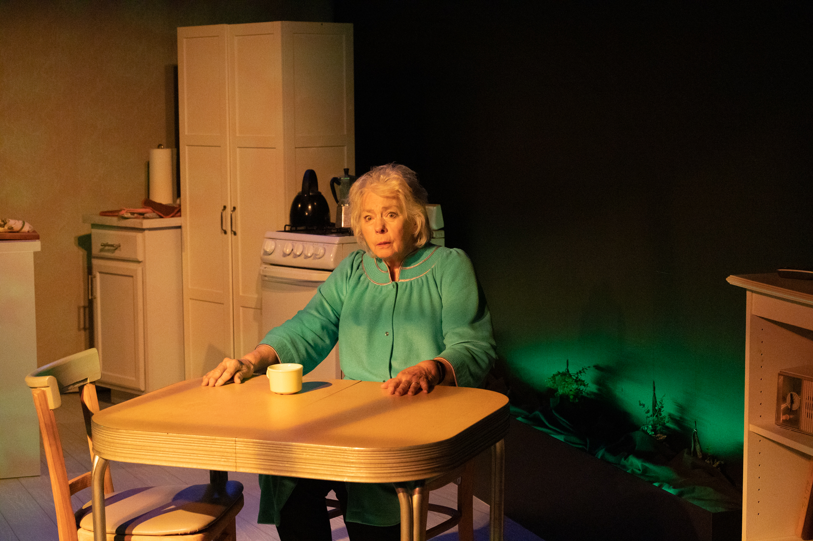

Juliet is losing her marriage. Her mother Pam is losing her memory. And there's a mysterious forest growing in and around their living room. Is it any wonder Juliet starts sleeping with one of her high school students? The Forest is a play about weird love and what to do when there aren't any right answers. To license The Forest for first class productions, please contact our office at (212) 221-0400.

